**STOCK WITHDRAWAL ADVICE (SWA)**

**Users Manual**

For Store Accounting – Viewing Only

Before you can enter to the system you must enter your user name and password, if ever you don’t have any login yet you may call IT corporate office and look for Feljun Bueno.

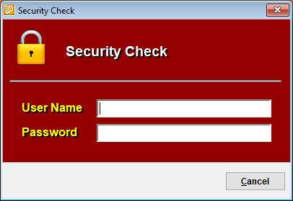

**Viewing the Stock Withdrawal Advice module**

From the main menu, select on stock withdrawal advice then, select stock withdrawal advice to enter to the stock withdrawal advice module.

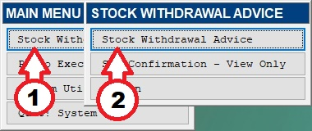

Then click on the Open button, then select existing SWA transaction or type the SWA transaction number then press enter or click on the check button below.

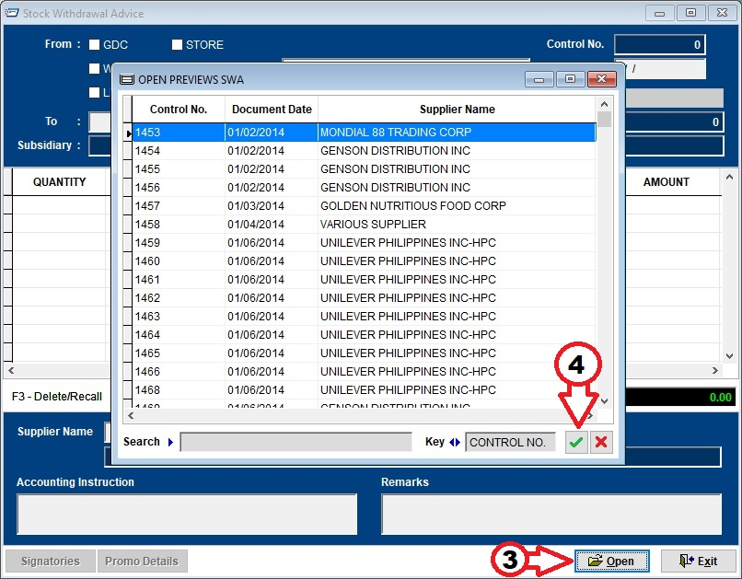

To view the Navision transaction number as supplied by the MIS personnel, click on the transaction number button located on the upper right corner as indicated below.

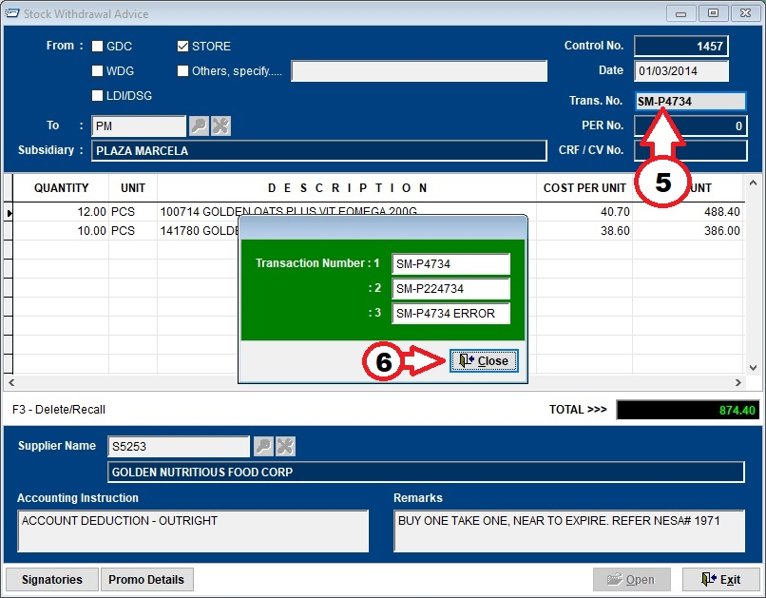

Another way of viewing the Navision transaction numbers is to select on the SWA confirmation from the menu.

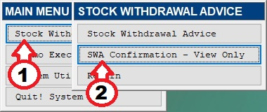

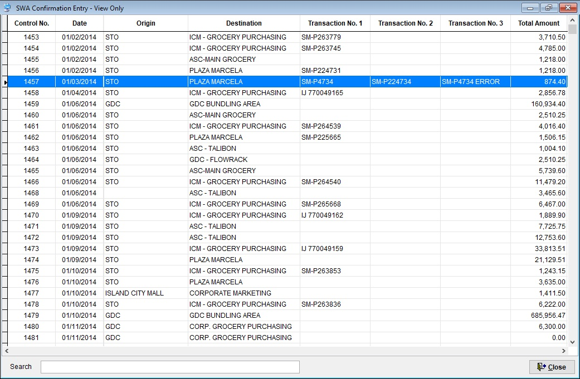

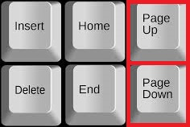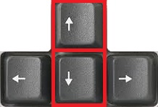You can navigate from the using arrow keys or page up and page down keys or just simply type SWA control number on the search text box below.

**Viewing Promo Execution Report module**

From the main menu, select on Promo Execution Report.

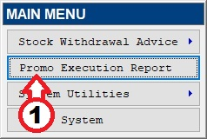

Then click on the Open button, then select existing Promo Execution Report transaction or type the PER transaction number then press enter or click on the check button below.

